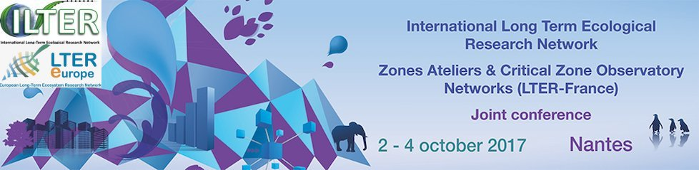
Call for presentations

October, 2nd – 4th 2017
Westotel Nantes Atlantique - 34 rue de la Vrière
44240 La Chapelle sur Erdre

Presentation title (Arial 14pt, bold):
Authors names (Arial 12pt):

Name of the LT(S)ER - CZO – Affiliation, postal and email addresses (arial 10pt):

Session in which your presentation proposal fits*:

Decision making, management and adaptive governance
Social-ecological system (SES) research, or “Putting the “S” in LTSER
Global initiatives
Biogeochemical cycles
Biodiversity and ecosystem services
Environmental risks
Poster session: Sensors and analytical tools
Free poster session
Speed talk for PhD students

*Please check the corresponding session

SUMMARY
(Arial 10pt) maximum 10 - 15 lines

KEYWORDS
(Arial 10pt) (5 keywords, in alphabetical order, comma-separated)

